PORTAFOLIO

CATALINA MORA

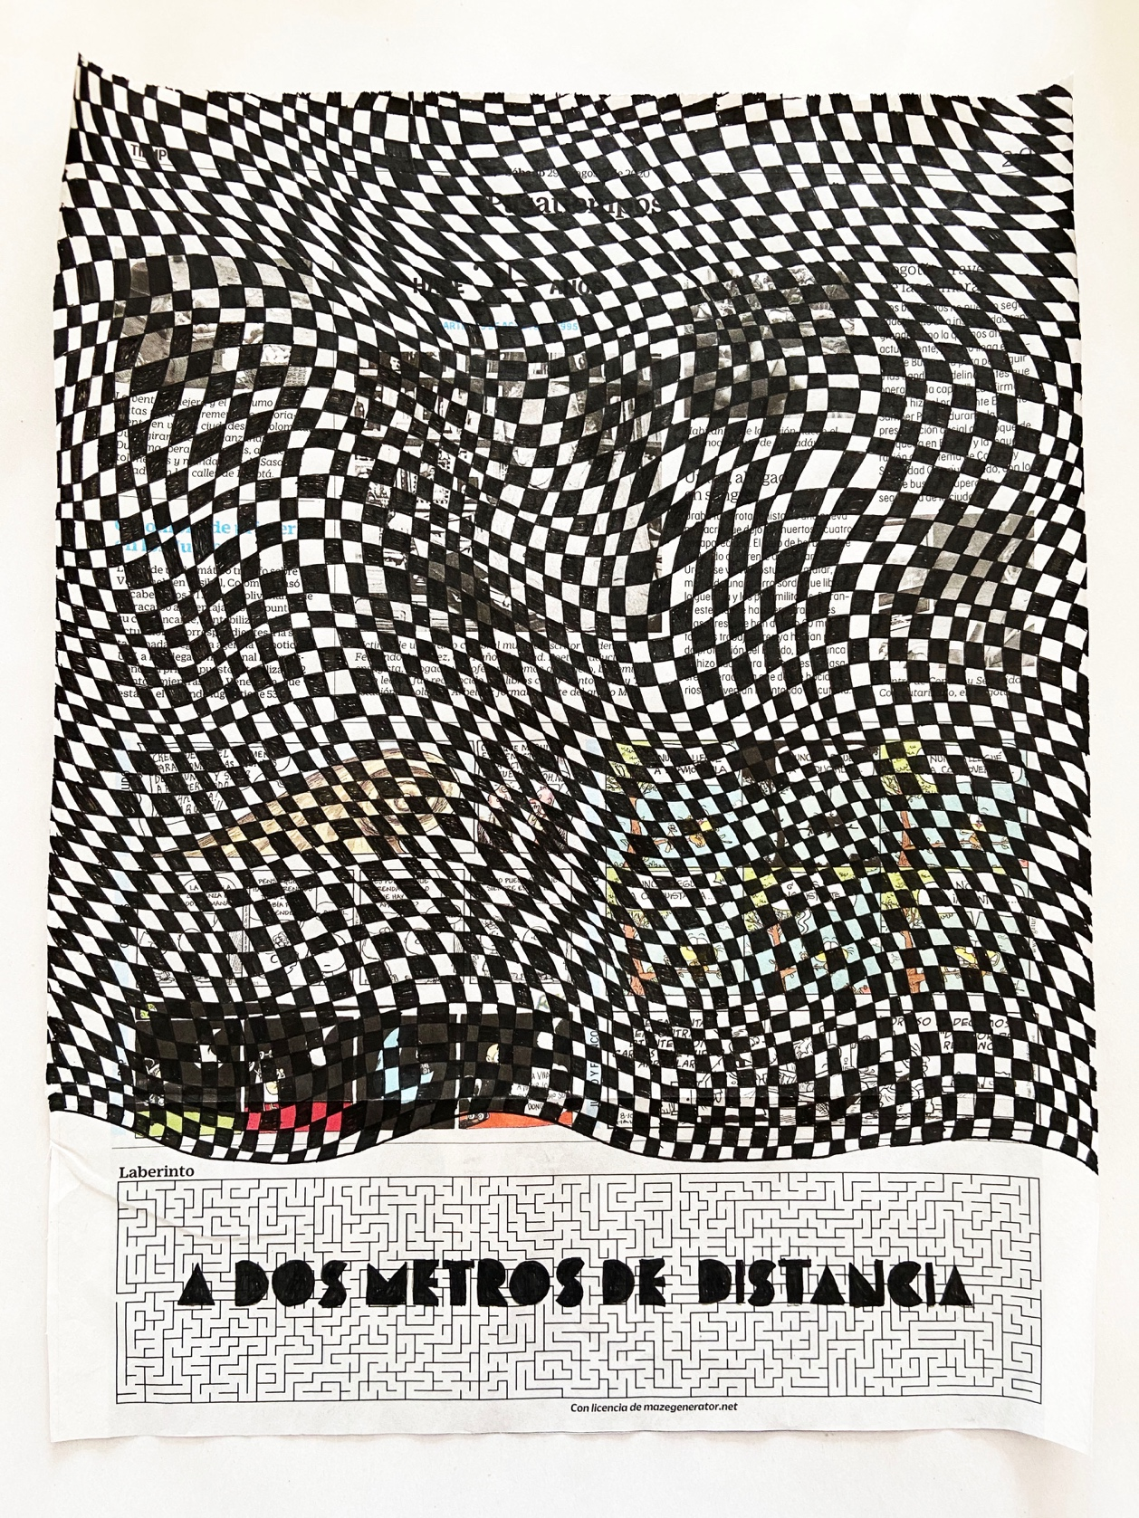

Title: "Entre la trama ando" (Between the plot I walk)
Technique: Drawing on newspaper
Year: 2021

CATALINA MORA
Bogotá - Colombia, 1988

Catalina Mora studied visual arts at the Jorge Tadeo Lozano University and completed a master's degree in art creation at the same university. Some of the recognitions obtained are: XVII national recognition from the regional artists' salon and participation in the Barcu fair in 2020, 3rd place in the III Young Art Salon of the Gilberto Alzate Foundation and the scholarship for unpublished publications of regional interest in 2019, a scholarship for the realization of individual exhibitions and participated in the New Names program with his work "Desolate Landscape" at the Gold Museum in 2018, selected in the Arte Cámara section at ARTBO in 2017, nominated for the Sara Modiano award in 2016, first place of the 8 Young Art Salon of the El Nogal Club in 2015 and participation in 8 Regional Image in 2014.

At the same time, she has exhibited her work collectively in different parts of the country, such as: the Museum of the Bank of the Republic of Bogotá, Gold Museum, Hoffman House Gallery, Gilberto Alzate Foundation, Yopal House Museum July 8, Bogotá Platform , Rojo Galería, Club el Nogal, in Flora ars + natura in Bogotá within the cabinet program, Banco de la República de Tunja, Galería Nueveochenta, Museo de Artes Visuales de Universidad Jorge Tadeo, LA gallery, at the ARTBO fair and at the million dollar fair.

The projects developed by Catalina explores the landscape from various aspects. From the most physical, to problems, economic, political and personal memory. And that is where she remembers a great archive of experiences that come from her childhood and have to do with the moments when her hands learned to relate to animals and materials, as if her hands had memory. From there arises the need to write, draw and do. For this reason, she explores not only the concepts of memory and forgiveness but also the archive within different materials and questions herself about how the individual dissolves within its territory or environment and how they are affected by external gestures, overwhelming lives and cultural practices.

In addition to her personal projects, Catalina is a co-founder and member of the committee of an ONG Called La Palmita, Research Center and leader of the La Caballeriza project, a cultural project located in the La Palmita Nature Reserve in Trinidad - Casanare.

Catalina lives and works between Bogotá and Yopal.

Artist webpage: www.catalinamora.com
La Palmita webpage: www.lapalmita.com.co

CURRICULUM

STATEMENT

My artistic practice has approached the landscape from various aspects. From the most physical to the economic, political, and personal memory problems.And that is where I recall a great archive of experiences that come from my childhood and have to do with the moments when my hands learned to relate to animals and materials, as if my hands had memory. From there arises the need to write, draw and do.

For this reason, I am interested in the concept of memory, oblivion and the archive in the landscape, since it is a scenario where contrary forces that affect the being are evident, that is why I am interested in how the individual dissolves when his territory or environment is affected by external gestures, overwhelming lives and cultural practices. And from these concerns arise a series of photos, sculptures, machine landscapes, videos and drawings that make up the installations, like a kind of landscape that reveals new relationships of meaning between each of the components.

EDUCATION
- 2007-2012: Bachelor in Plastic Arts at the Jorge Tadeo Lozano University.
- 2015-2017: Master in Plastic Arts from the same University.
​
SOLO EXHIBITIONS
- 2018 - Efecto contra Causa (Effect versus Cause) - Casa Museo 8 de Julio de Yopal
​
SELECTED GROUP EXHIBITIONS:
- 2011 - Libro Árbol (Mark Dion) – Plataforma Bogotá
- 2013 - Figuras Emergentes- Rojo Galería
- 2013 - 7 Salon de Arte – Club el Nogal
- 2013 - Gabinete Colectivo – Flora
- 2014 - Imagen Regional 8 – Banco de la República - Tunja
- 2014 - Séptima Versión - Arte Joven Colsanitas - Embajada de España
- 2015 - Imagen Regional 8 - Museo de Arte Banco de la República - Bogotá
- 2015 - Revuelta - Museo de Artes Visuales - Tadeo - Bogotá
- 2015 - 8 Salón de Arte Joven - Club el Nogal
- 2016 - Feria del Millón
- 2016 - Exposición: 1 1/2 x 1/4 - Club el Nogal - Diciembre
- 2017 – Arte Joven Colsanitas - Embajada de España
- 2017 – Arte Cámara – Feria Artbo
- 2018 - LA Galería – Exposición “COSMOS”
- 2019 - Fundación Gilberto Alzate - III Salón de arte joven
- 2020 - Feria Barcu
- 2021 - Luciferinas - Casa Hoffman
​
GRANTS/RESIDENCIES/AWARDS
- 2014 - 2015 Seleccionada para la segunda fase de Imagen Regional 8.
- 2015 - Ganadora del premio - 8 Salón de Arte Joven - Club el Nogal.
- 2016 - Nominada al Premio Sara Modiano
- 2018 - Nuevos Nombres - Banco de la República
- 2018 - Beca para la realización de una exposición individual - Programa de Estímulos 2018
- 2020 - Reconocimientos Nacionales XVII Salones Regionales de Artistas (virtuales) 17SRA Región Orinoco Amazonía

PROJECTS FORMUTALED AT LA CABALLERIZA. Scholarships/Awards

- 2019 - Scholarship for unpublished publications of regional interest - Stimulus Program of the Ministry of Culture.
- 2020 - Scholarshipo - "Comparte lo que somos" – Craft Kit – Leather Whipper –Ministry of Culture Program.
- 2020 - Consolidation Grant for new cultural business lines - incentive Program.
- 2021- Artistic Residence on the traditional use of leather - Ministry of Culture Concertation Program.

PUBLICATIONS
- 2012 - Catalog of the exhibition, Mark Dion, Book-Tree. ISBN: 978-958-8471-59-4
- 2015 - The Return of the Bear goes Pa'lante. picture book-. ISBN: 978-95859046-0-6
- 2016 - Regional Image Catalog 8, Art Museum of the Banco de la República. ISBN: 978-958-664-310-
- 2018 - "New Names" Catalog. ISBN 978-958-664-393-1
- 2019 - I have it on the tip of my tongue - ISBN 978-958-59046-7-5
​
COLLECTIONS
- Private collection of the club el Nogal - Puzzle.

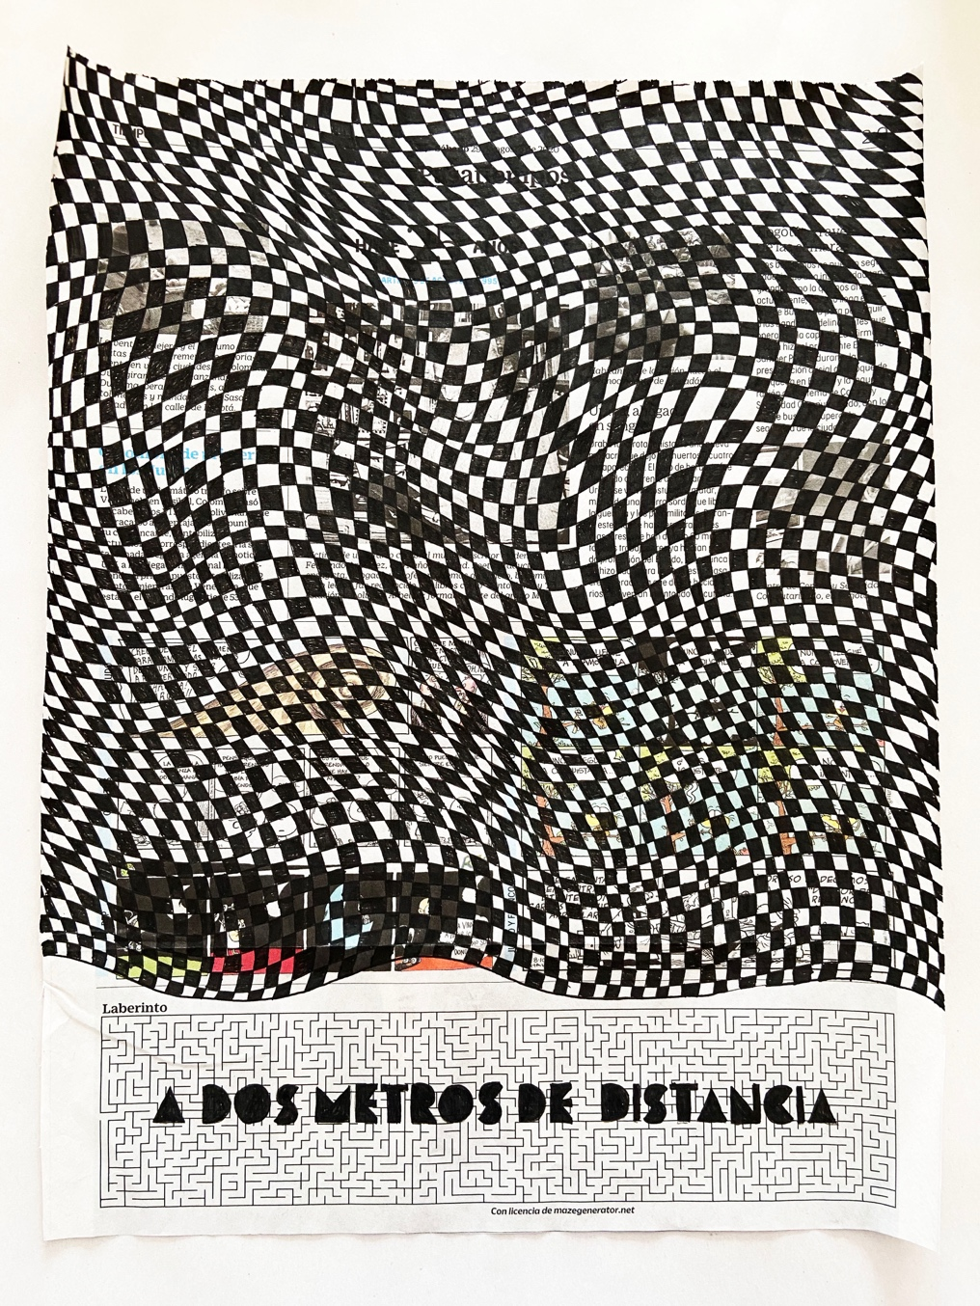

Between the plot I walk
Drawing on newspaper
Various drawings and a notebook
2021

It was never so important to build the future, the one who resists survives, a comforting green soup that is very easy to make, a titanic task, Colombia takes care of Colombia, which the dead have taught us in times of pandemic and two meters away. Some titles that have accompanied us during the quarantine period and many Colombians who have lived in their homes. Between the plot and I is a project in which I am interested in letting time pass through the exercise of drawing different plots on the newspaper "EL TIEMPO", where the titles and subtitles are woven with the drawing until it makes it difficult for the viewer to read, as a way of forgetting our present, filing our memory of the drama of our country and criticizing the same medium about the circulation of information.

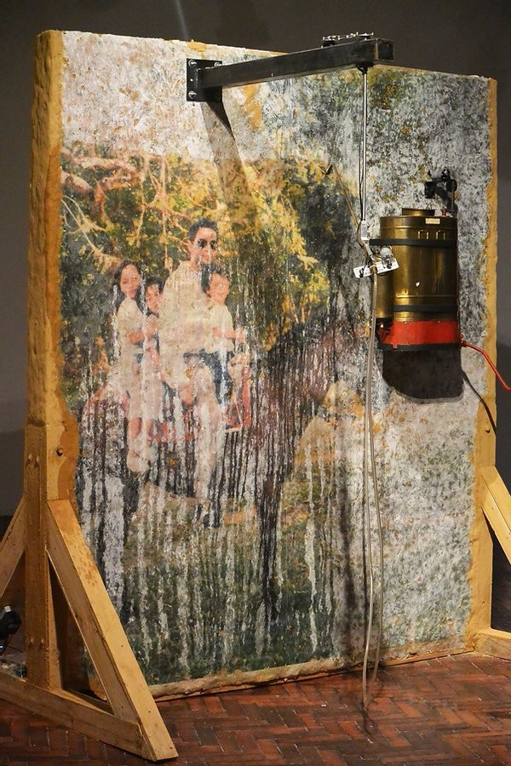

Effect against cause "Fumigador"
Bareque and photographic transfer
2 meters x 1.5 meters
2019

Simultaneous memories of different orders appear in my mind in a disorderly way: moments in which I learned to relate to animals and materials as if my hands had memory and questions about the modification of the cultural practices of the plains that contribute to their extinction. For this reason, I am interested in the plains landscape or its surroundings subjected to interventions that I do not control and that are unleashing a future situation of contamination that is overwhelming lives, cultural practices and common ways of life that gave meaning to living in the plains.

These random movements of my machines are accompanied by uncertainty, they cannot march constantly, they do what I have not been able to do, erase from my memory what I have left behind and what I could have done and did not do, although they are the ones that they remain in space, constantly reminding me of my starting point, my helplessness as an individual affected by a diluted territory.

However, the viewer will have in his hands an atomizer in which he will sprinkle water on the photographs, the photographic image will come to life with the water regardless of the machinic gesture, as a way of resistance against oblivion, the sprinkling of water evokes our past to stop at it. As Walter Benjamin would say: it is necessary to keep the past in sight.

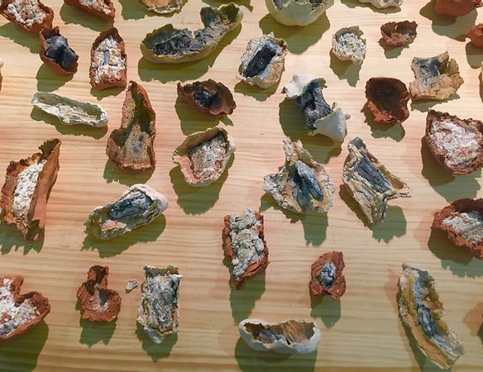

For some time I have been interested in the versatility of clay in registering the footprint, the trace of various materials and in this case it seemed pertinent to find a hidden writing in the oldest and most ornate fossil of the past, such as coal. And it is there, where I begin to contemplate that game without forms, as if it had content, as happens with the letter and the image, as with the letter and the image, the letter is no longer the origin of the image, now the image can be the origin of the letter to build your alphabet.

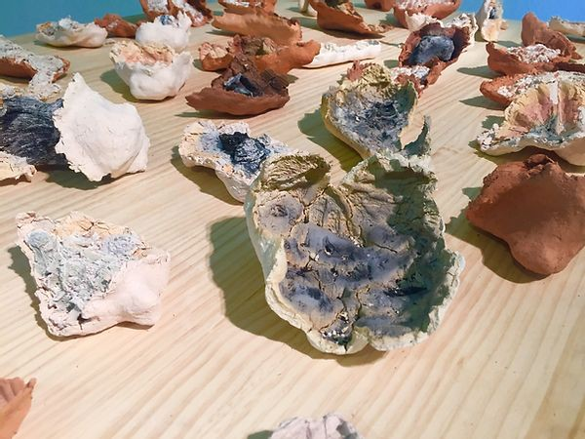

Signs of time
Ceramic carbon footprint
Variable measures
2018

What is the letter or image made of?
Link video: https://vimeo.com/user22957327

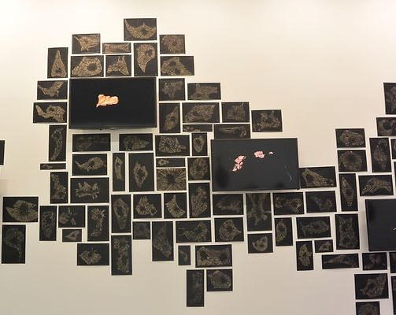

I am interested in the exploration of the moving image and flow of the red light of the coal on the same body. Hypnotized by the light and sound, they produced the isolation of the things that surrounded me, facing me to decipher a cryptogram, where the sound and the image evoked other interior sounds of the earth and the movements of the tectonic plates, it was possible to listen to your guts and your heart; a visceral vision of the center of the earth.

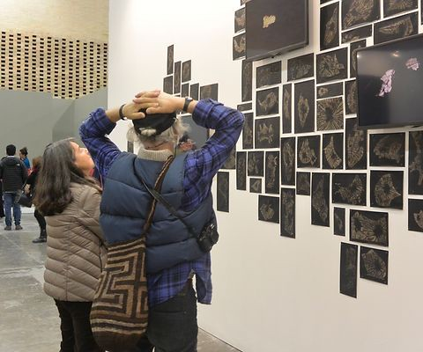

A trip to the center of the earth
Videos of the red light of coal and drawings and frames of the light on carbon paper
Variable measures
2017

That cryptogram of drawings on paper and videos of the red light illustrated as a very simple thing can explain the idea of origin. These images bring us closer to microorganisms and the times of the Carboniferous periods where scientific findings ensure the evolution of amphibians. So I am interested in how some artistic gestures can explain the mysteries that have accompanied humanity "the origin of life", science fiction anticipating the construction of other worlds and have us face the unknown.

Link video: https://vimeo.com/user22957327

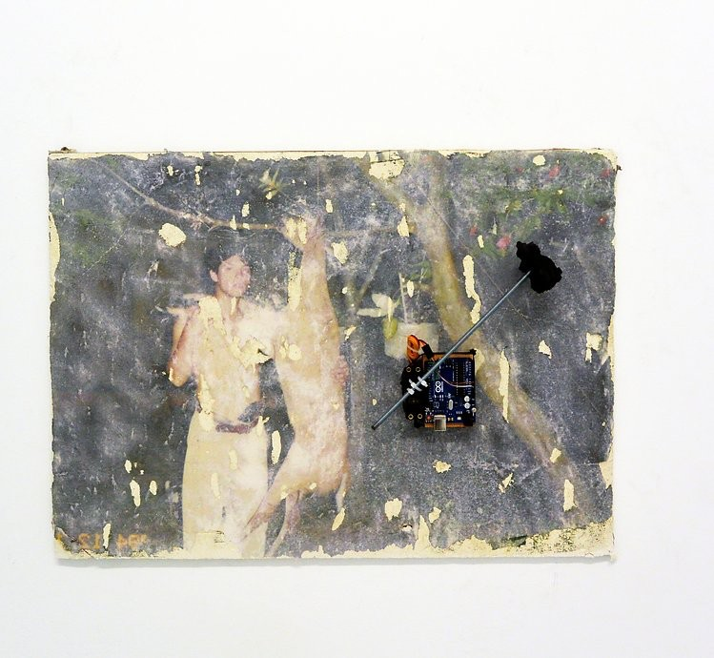

The line that the machine makes on the photograph anticipates its destruction, although the photo comes to life each time it is affected by the gesture. It is not a drawing on the photograph but what we see are random movements produced by an effect against oblivion, a memory linked to the photographic archive that this photo belongs to. Then the drawing becomes a movement to come because it seems that it is waiting for an answer or an announcement will be manifested.​

Time is in perpetual uncertainty
Photographic transfer and machine
50cm x 70cm
2016

However, I don't really know if I am conjugating in the past, present or future. As Roland Barthes says: "time is in perpetual uncertainty."

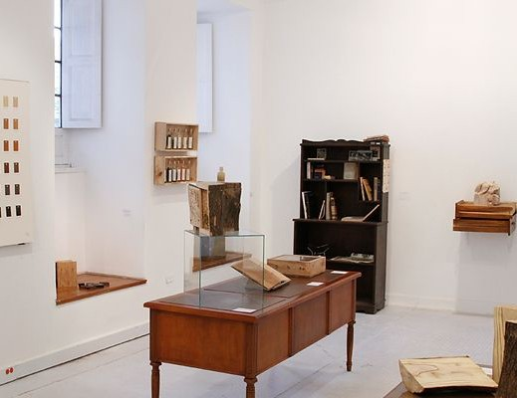

The Libro-Tree laboratory, a project carried out in Bogotá, where several artists and students from other disciplines made the workshop possible, in which it was directed by the artists Mark Dion and Felipe Arturo. This workshop had the objective of building a wood library, an original practice from the 18th century, presented in the 13th edition of the Kassel dOCUMENTA and each participant would make their own version of a tree-book.

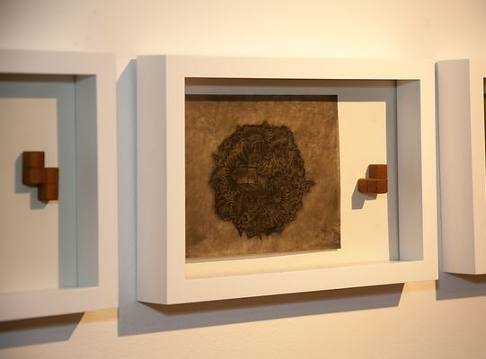

Puzzle
7 drawings - the tree book
2015.
This piece is in the private collection of Club el Nogal

My Book-Tree wanted to portray the tree (make a small physiological description), where physical characteristics such as: the leaf, the stem, the flower, the seed and the fruits are united, building a mass, each characteristic was assembled from a logical structure organized inside like a puzzle and a chaotic structure outside. It was not a book, it was an indefinite mass that sought to be defined, by means of a board game to assemble.

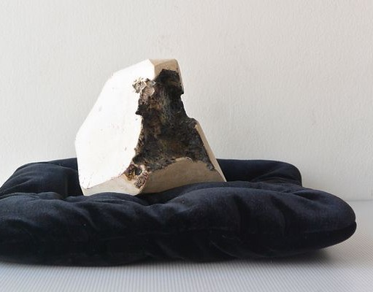
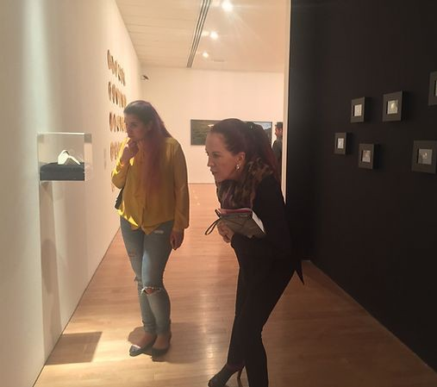

Precious stones
7 videos - ceramics
Variable measures
2014

By observing in detail how fleeting the red light of coal is consumed and feeling the impossibility of controlling its propagation, I build a diamond, where in it, the coal leaves its mark. So I saw an incomplete, wounded stone, which made me think about all the absurd things that human beings have done to dominate natural resources. Mastering a force and not letting it be.

Link: https://vimeo.com/user22957327

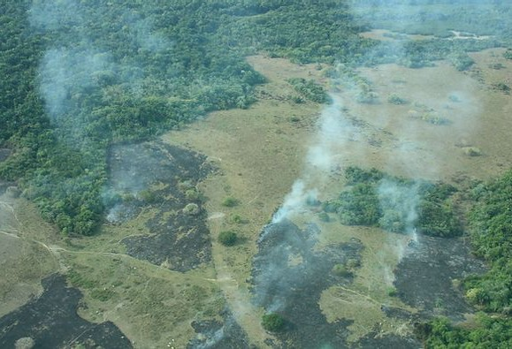
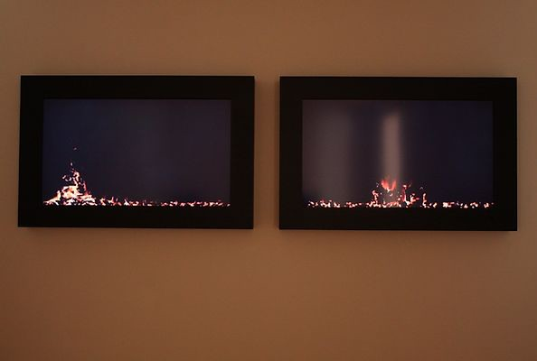

Desolate landscape
2 videos - 15 minutes
Variable measures
2013

It is a diptych of two videos that form a landscape on fire. See the fire walk in the savannahs, see a pure embers on the plain, the smoke billowing overhead with a smell of reed and honey. Fire and wind draw the landscape, although man in constant search for oil finds have managed to extract all the material, changing the cultural dynamics of landscape management, abandoning the lands, then, the isolation of those spaces of origin of the material they leave a trace of the ruin of progress, creating an empty and barren landscape.

Link : https://vimeo.com/user22957327

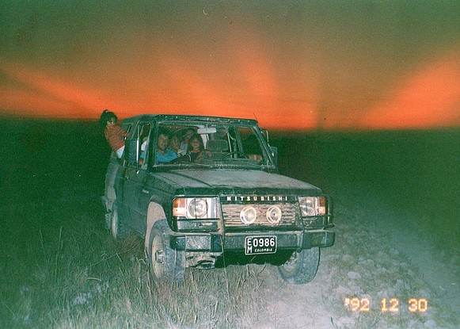

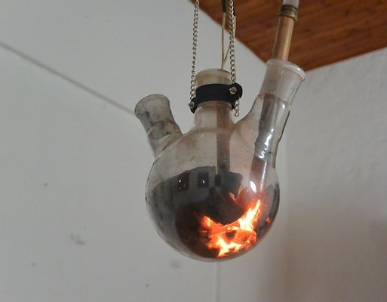

“ Sun”
Landscape machine
Installation ( machine
2012 - 2018

That orange light that is the sunrise and sunset of the plain, which has always accompanied it, is as if it were that red light of coal, a delightful and essential light that gives off the energy of change, a light of deterioration, a light that records a place with an end, a new beginning, and a story to tell. It is a light that has sheltered everyone. It is here where the landscape becomes a machine, an interesting strategy that allows the materialization in space of various aspects that the landscape involves. From the most physical to economic, political and personal memory problems.

Link: https://vimeo.com/user22957327

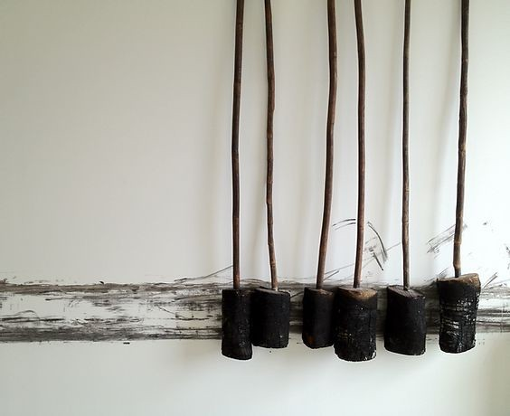
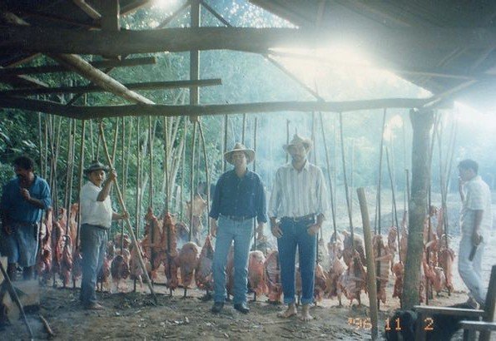

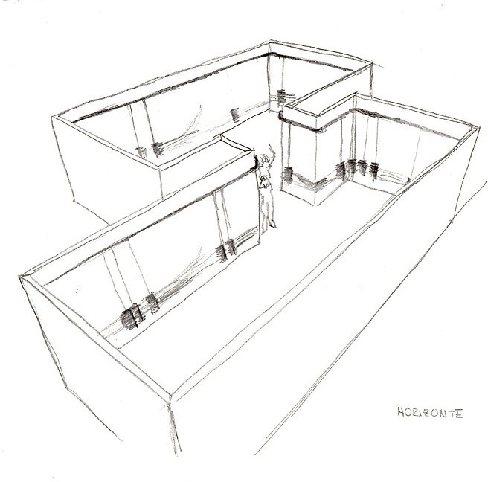

The horizon
Drawing in space
Variable measures
2012

The drawing made by charcoal, a line expanding in space creating a horizon around a closed space, where its extension depends on the number of walls that the viewer can draw on them, recreating a new place. (The cubarro sticks are originally used to grill the meat, here they are used to support the charcoal logs that roast the meat, that is, the coal is cooked and not the meat).

PUBLICATIONS

“La vuelta del oso va pa´lante”, It arises from interviews with the community of the la cañada village of the municipality of Trinidad, about the transformation of the landscape. The palm bear becomes the voice of the community crossing the flooded savanna facing different episodes in the landscape.

At the end there is a glossary of the scientific, common and natural cover names of the plain. Illustrations Catalina Mora and text Cachi Ortegón.

“ Lo tengo en la punta de la lengua” It is a book that compiles traditional and popular riddles of the plain, in which we were awarded the scholarship of the Ministry of culture "unpublished publications of regional interest" Illustrations Catalina Mora and text by Cachi Ortegón

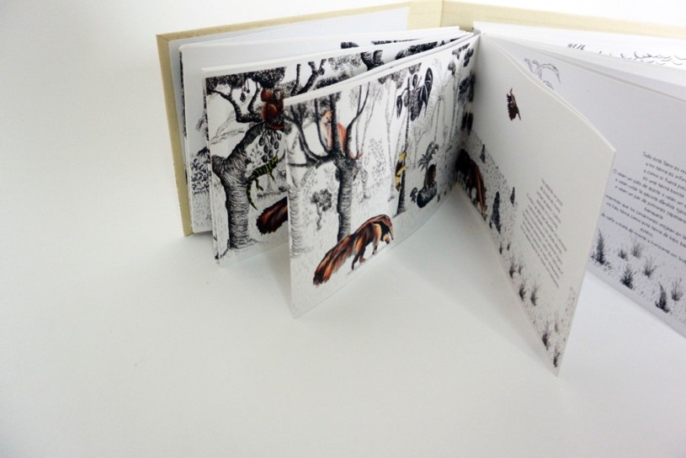

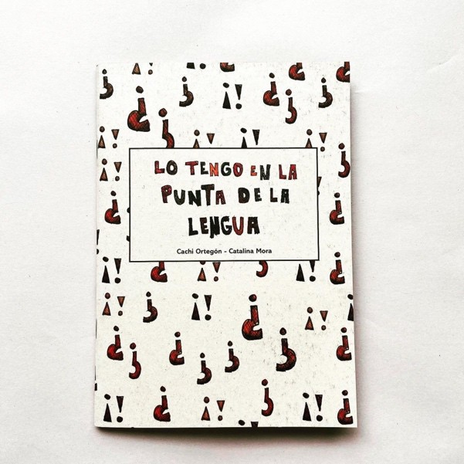

PROJECT LA CABALLERIZA

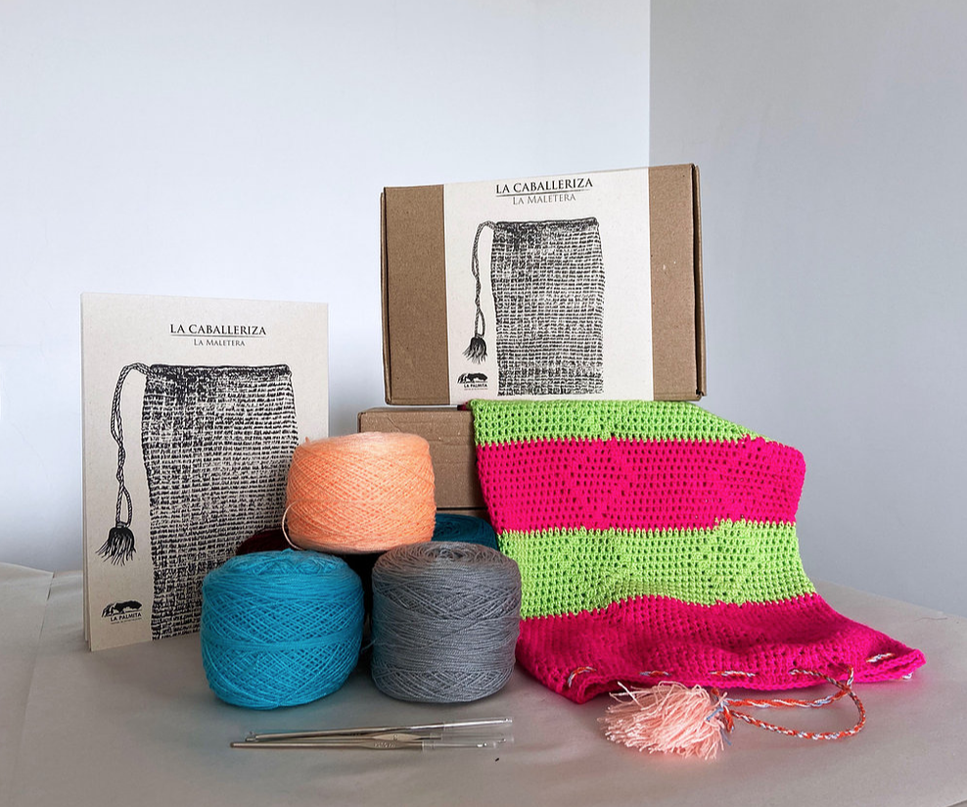
The handmade KITS
Make a llanera craft from your home in the company of a local craftsman using virtuality. Kits: The Leather Azortador, La Cirrampla and La Maletera.
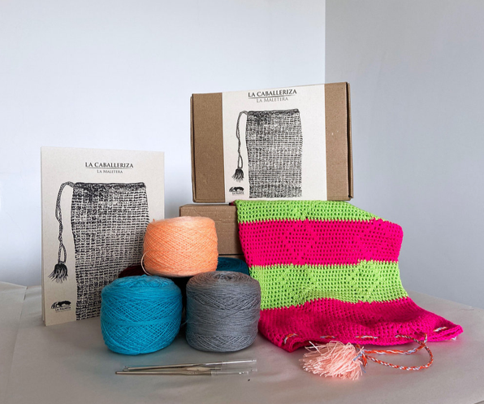
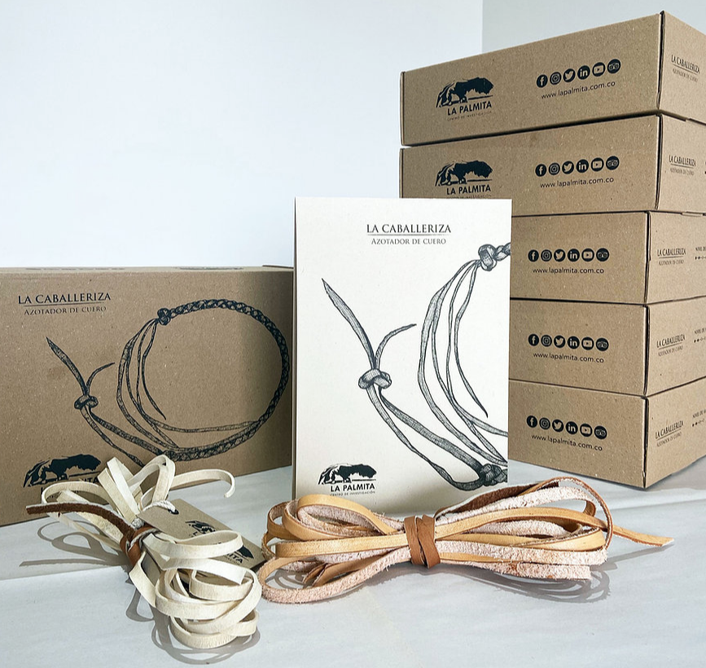
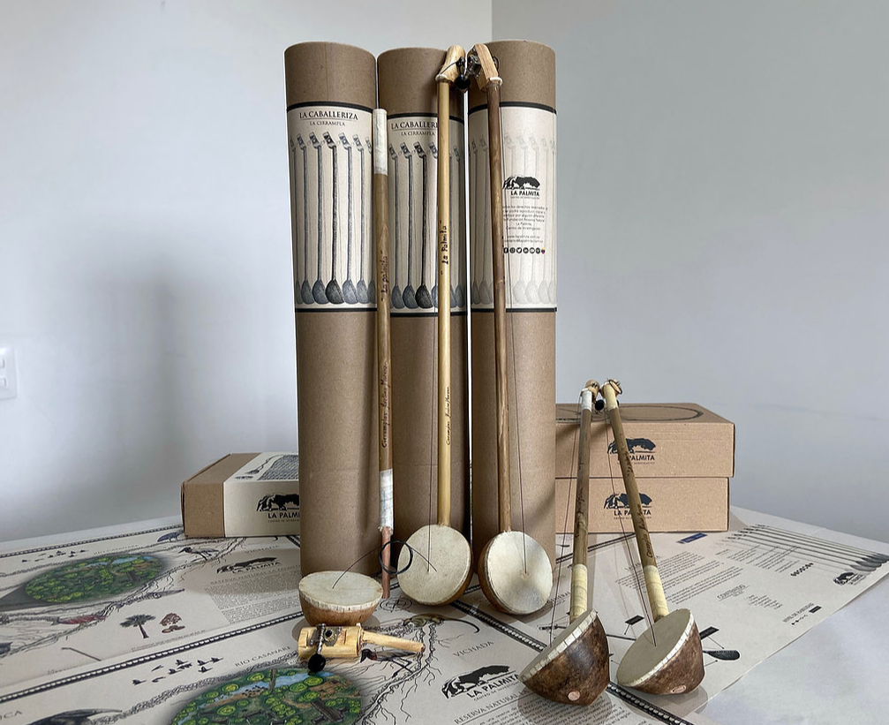

The artistic residency on the traditional use of leather

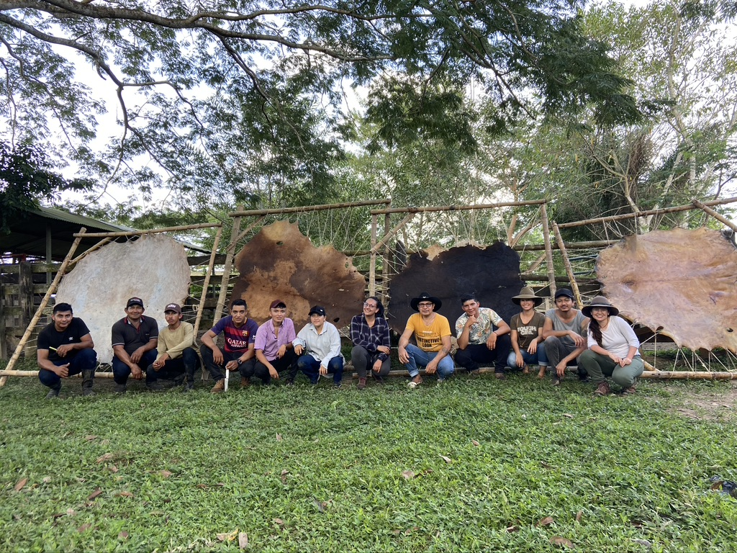
It seeks to generate the appropriation of knowledge about the traditional use of arts and crafts, through the exchange of knowledge and different ways of doing things between visitors, artists, young people and the community.

